Questions –

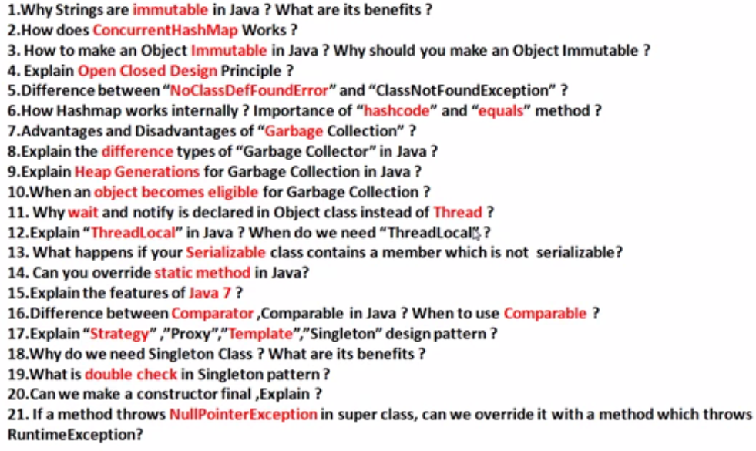

#1 – For StringPooling , String is immutable it can safely shared between many threads  
Read more: <http://javarevisited.blogspot.com/2010/10/why-string-is-immutable-in-java.html#ixzz3J1jefKXM>

#16, #17, #18, #20,

Difference between wait and sleep in Java?

Difference between Hashtable and HashMap in Java?

Difference between checked and unchecked exception in Java

Example of checked Exception in Java API

IOException

[SQLException](http://javarevisited.blogspot.com/2012/01/javasqlsqlexception-invalid-column.html)

DataAccessException

[ClassNotFoundException](http://javarevisited.blogspot.com/2011/08/classnotfoundexception-in-java-example.html)

InvocationTargetException

Example of unchecked Exception in Java API

Here are few **examples of Unchecked Exception in Java** library:

NullPointerException

ArrayIndexOutOfBound

IllegalArgumentException

24. Difference between Serializable and Externalizable

DI

Scope of bean – default is Singleton

AOP

Spring modules

View resolver

Transactions

Annotations

Spring Security

Password Encryption

* What are the major differences you can state while using SOAP or REST, in terms of

applicability as concern?

Some of the differences that may be observed in applicability of SOAP or REST as the

service language/specification :

1. When requirement is to provide a business process as a service, then SOAP may get

little more attention than RESTful services.

2. When we are exposing a server side object as many different type of representations

for the client, such as JSON, TXT, XML, Audio, Video and many more (HTTP content types)

etc. RESTful services can be used/more appropriate than SOAP.

3. In case of contract/interface based service definitions are to be used, then SOAP can be used.

4. In case of exposing a service for any type of devices, be it Desktop/Laptop/Netbook, Tablet,

Mobile phones, Kindle etc., and consumer can be a browser (Thin client) or a native application

(Thick client). In this circumstances we can opt for RESTful services.

5. In case of many different types of transports are to be used for using a service, then SOAP would

be appropriate over RESTful service.

6. For looking for standards-based service declarations and usage, SOAP has many standards to use,

such as WS-* standards. Whereas RESTful services would be a specification way of exposing and

using any service.

7. Looking at slightly more technical aspects of SOAP, SOAP supports custom objects definitions using

XML Schema and marshalling/unmashalling of various datatypes to communicate across diverse platforms.

* How can you apply security to RESTful services

Some of the options available to use for securing a RESTful service, for now, are

1. Basic Authentication

This type of Authentication will require transport level encryption(SSL), as user

credentials are to be sent via wire in plain text.

2. OAuth 1.0a / OAuth 2.0

OAuth 1.0a is using advanced encryption for passing token for authentication purposes.

OAuth 2.0 is using SSL for transport level security.

3. Custom/Third-party security protocol